**Question 1**

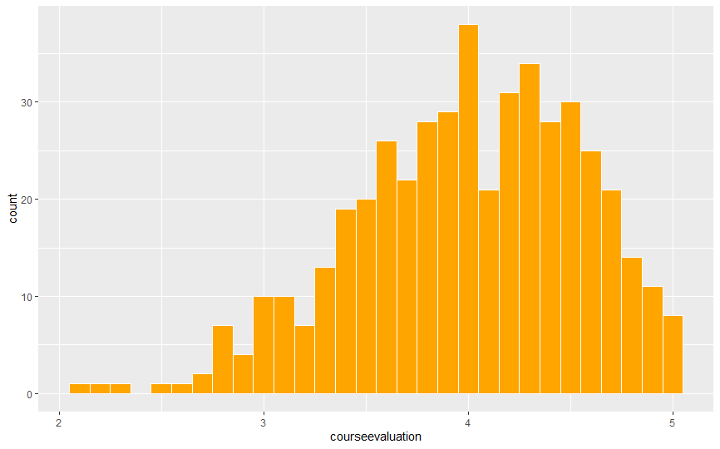

The graph above is not a normal distribution since the distribution does not have the perfect bell shape. The distribution is skewed more to the left, which means the course evaluation values are smaller than the average. The distribution shows that there are more bins to the left. When the mean and standard deviation is calculated for the course evaluation, the mean is 3.99, and the standard deviation is 0.55. The course evaluation score of 3 is two standard deviations away from the mean. Thus, a course evaluation score of 3 is far from the central number, 3.99 but 2 standard deviations or approximately 1.

**Question 2**

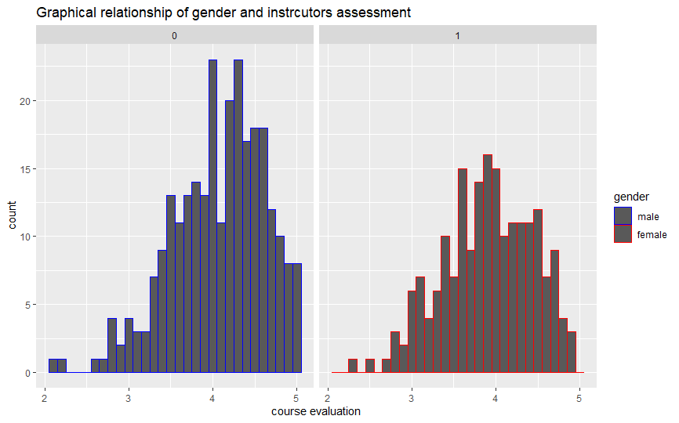

From the graph, male instructors have a higher score than female instructors. Additionally, both graphs are skewed to the left, which means both instructors scored lower values since there are more bins to the left from the mean of 3.99. Most of the observations are clustered around the mean. Most of the observations are within two standard deviations from the mean (mean = 3.99, standard deviation =0.55).

On average male instructors had a higher score away from the mean than the female instructors. On average, students prefer male instructors to females. Students perceive male instructors' teaching style as more effective and enhance learning. Additionally, I would recommend a teaching workshop for female teachers to equip them with skills to meet students' needs. Working conditions should be improved to motivate both male and female teachers. The incentives could include offering paid vacations, tenure track positions, and allowances.

**Question 3**

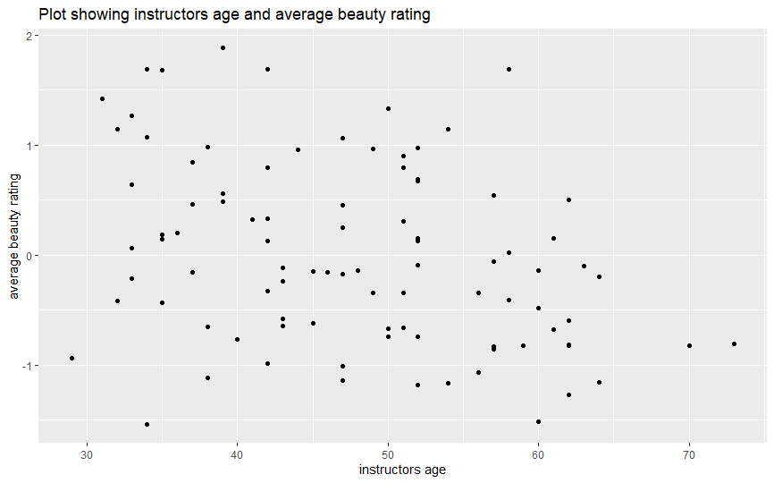

The plots on the graph suggest a majority of the professors are between the ages of 30 and 65 years. The highest beauty scores (above 1.5) were among professors between 34 and 42 years. However, a professor closer to 60 years was scored 1.7. The lowest beauty scores, -0.48 and -0.5, were a 34 year and a 60-year-old instructor respectively. The results mean a professor’s age has less influence on their beauty rating.

Also, the data shows majority of the professors are 50 years and below, which means the faculty has more years to serve. At a glance, it appears there was an equal number of professors rated above and below average beauty of 0. From 30 to 40 years and 1.5 to - 0.2 on the average beauty rating, it can be observed that the average beauty rating decreases as the age increases. Also, focusing on age 35 to 45 and -0.9 to 1.4 0.5 to 1 on the average beauty rating, we can observe a positive relationship between average age rating and instructors age.

**Question 4**

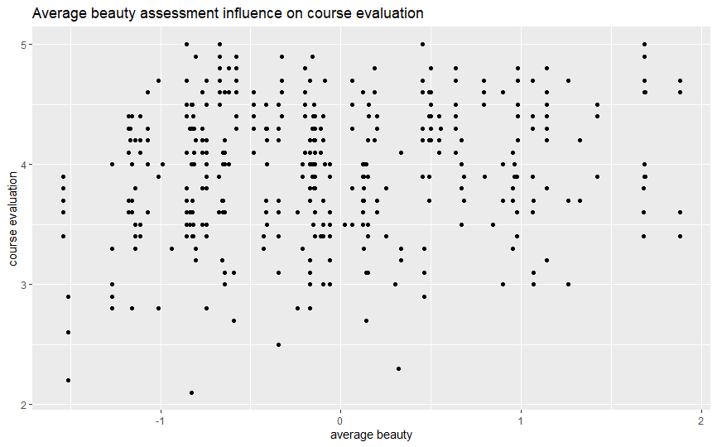

From the graphs above, the least course evaluation point was not the instructor with the least average beauty. The least evaluation score was around average beauty of 2.2 was an instructor far from the least average beauty of -1.6. Also, the highest evaluation score (5) was spread between instructors with less and more average beauty. For example, instructors with average beauty of – 0.8, - 0.6, 0.4, and 1.7 scored the highest point. Also, most of the observation was clustered between average beauty of 0.5 or less from the graph. The results imply that beauty has less influence on course evaluation instructors receive. And the beauty of an instructor does not determine the score.

**Question 5**

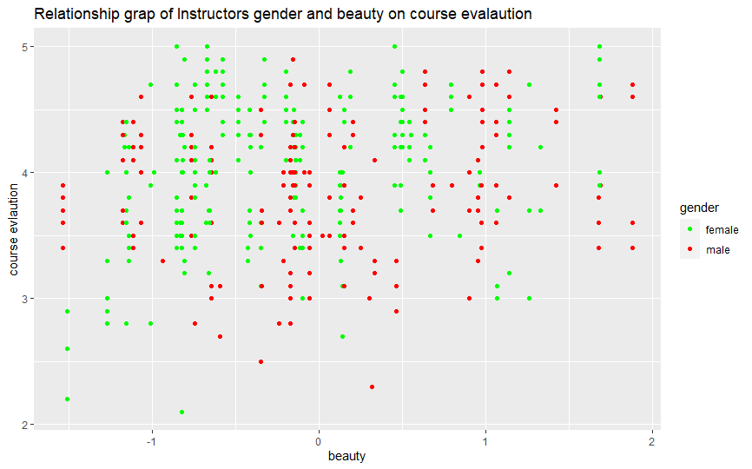

The graph has more females scoring higher in course evaluation (5). The red points representing males are clustered between 3 and 4 of the course evaluations. Majority of the male and female instructors were scored between -1 and 1 on the beauty scale. In contrast, male instructors received the lowest (-1.48) and highest (1.8) beauty scores. And the female instructors received the lowest (2.1) and highest (5) evaluation scores. Based on the high evaluation score among female instructors, they have higher chances of winning awards, grants, promotion, and tenure track positions. On the lowest point of the beauty score, there is a close score for male and female instructors (-1.49 for females and -1.48 for males). In contrast, on the higher end of the beauty score, there is a wider gap between male and female scores (1.7 for females and 1.9 for males).

Question 6

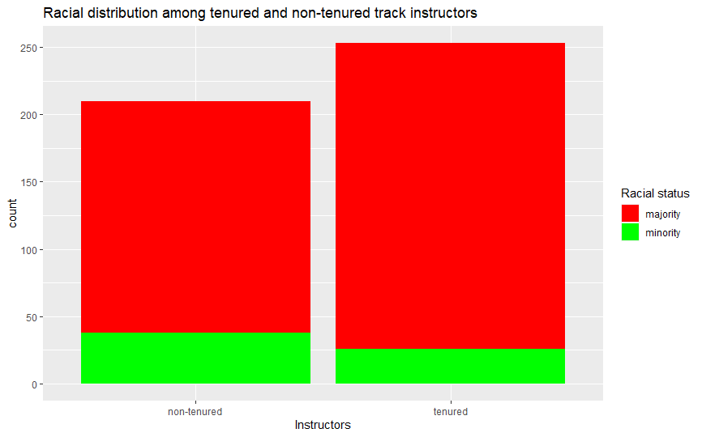

The distribution shows that the racial majority is more in tenure and non-tenure instructors. The administration should consider employing instructors within the racial minority group to promote diversity. Much effort should be channeled into the tenured track instructors where there vast gap. Among the minority instructors, non-tenure instructors (75) are more than tenured track (25). However, tenured track members (225) are more than non-tenured instructors among majority race instructors (200). While I recommend the school appoint more minorities, there should be increased efforts to offer tenured track positions to employed minority members. In the interim, administrators could hold off on employing instructors within the majority race to ensure a more equitable faculty.

**Question 7**

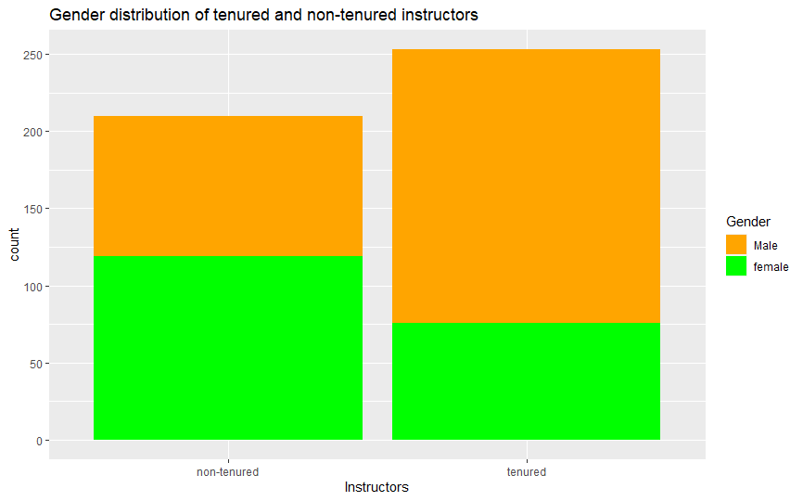

The diagram shows more non-tenured female instructors (123) than male non-tenured (80). On the other hand, the male tenured track instructors (180) are more than the female tenured track instructors (75). Among non-tenured track instructors, there are 43 more females than men. Additionally, there are 105 fewer females than males in the tenured track positions. The administration should employ a strategic plan in appointing instructors to promote gender balance. Further, the administration should prioritize filling tenure track positions with females over males to ensure increased opportunities for females.